|  |
| --- |
| Orange HRM Live Project |
| **Project Functional Requirement Specification Version 1** |
|  |
| **Prepared by : Angelica P A(845206)**  **Reviewed by : Raghavendra BN** |
|  |
|  |
|  |

|  |
| --- |
|  |

Contents

1. Purpose of the document: 3

2. Project Overview: 3

2.1 Audience: 3

2.2 Hardware and Hosting: 3

3. Information Architecture 3

3.1Performance............................................................................................................................................4

3.1a Configure 4

3.1.1 Key Performance Indicators (KPI’s) 4

3.1.2 Trackers 5

3.1.3 Manage Reviews 6

3.1.4 My Reviews 7

3.1.5 Review List 8

3.1.6 My Trackers 9

3.1.7 Employee Tracker........................................................................................................................9

4.Sign-Off Document 10

# Purpose of the document:

This is not a project plan. It is a guide for system architecture and development, not for phasing, timelines or deliverables.

This document is divided into three sections:

• Project Overview

• Information Architecture

• Site Design

# Project Overview:

## 2.1 Audience:

This document is intended as a complete guide for ESS-User in using Orange HRM 3.0. This

Document is specially designed for non-specialists; specialists may find the document a useful point of reference. By reading this guide, you will learn how to use Orange HRM through the elements of the graphical user interface and what's behind some of the advanced features that are not always obvious at first sight. It will hopefully guide you around some common problems that frequently appear for users of Orange HRM.

## 2.2 Hardware and Hosting:

Orange HRM’s servers will be hosted at X company’s site.

Orange HRM will be hosted on two servers: One to host the actual website and (language)code , and the other to host the (database name)database.

# Information Architecture

Log in to the Orange HRM System using your ESS-User account that has been created by the HR Admin

As shown in the figure 3.1

Figure 3.1:

.

# 3. 1Performance

Performance module is a very effective and crucial module in Orange HRM page for assigning the Key performance indicators for a particular job and also for reviewing and tracking each employees in the company It is a very useful tool for HR since the review tracking for not only the employees but also for the Hr is also indicated in this module. Now let us analyse each of the sub modules in detail.

# 3.1a Configure

The first sub module in Performance module is Configure. When the user clicks on the Configure tab there is a listing which contains two options.

### 3.1.1 Key Performance Indicators (KPI’s)

In the Key performance indicators we can add our own Key performance indicators according to our companies’ policies. As shown in the figure we can add KPI’s using the add button and user can also assign maximum and minimum ratings according to the HR’s point of view and company structure. Different job titles can also be added likewise.

Figure 3.1.1:

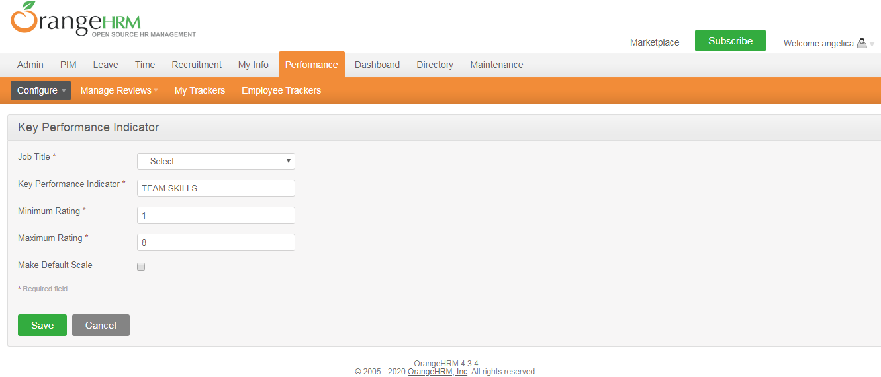

### 3.1.2 Trackers

In the Tracker sub-module we can add the tracker name. It can be assigned the name of HR itself. In the employee name we can type the hints and search for employees. Now we have two blocks such as available reviewers and added reviewers. These two blocks are separated by two buttons one is a green coloured add button and the next one is a red coloured remove button. The list of employees who are working in the company will be available in the first block i.e. Available reviewers.

The tracker need to select the required names from the available reviewers block and click the add button so that those names will be moved on to the added reviewers. Now if we want to remove any of the added reviewers from the list then the user needs to select those names and click the remove button so that those names will be moved to the available reviewers block.

Figure 3.1.2:

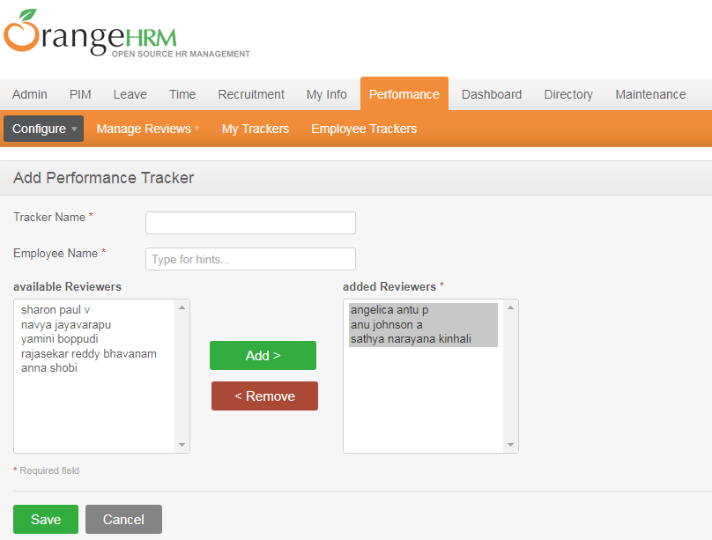

3.1.3 Manage Reviews

In the mange review sub-module of performance module the user can easily analyse the reviews given to each of the employees in the company just by typing the name of the employee. When we start typing the name of the employees several suggestions will arise so that it is easy for the user to get the reviews of each employees. It will also give the duration in which the reviews were made and also the reviewer so that it will be very helpful for future reference. The details mentioned above can be viewed clearly in the following Figure 7.1.3.

Figure 3.1.3:

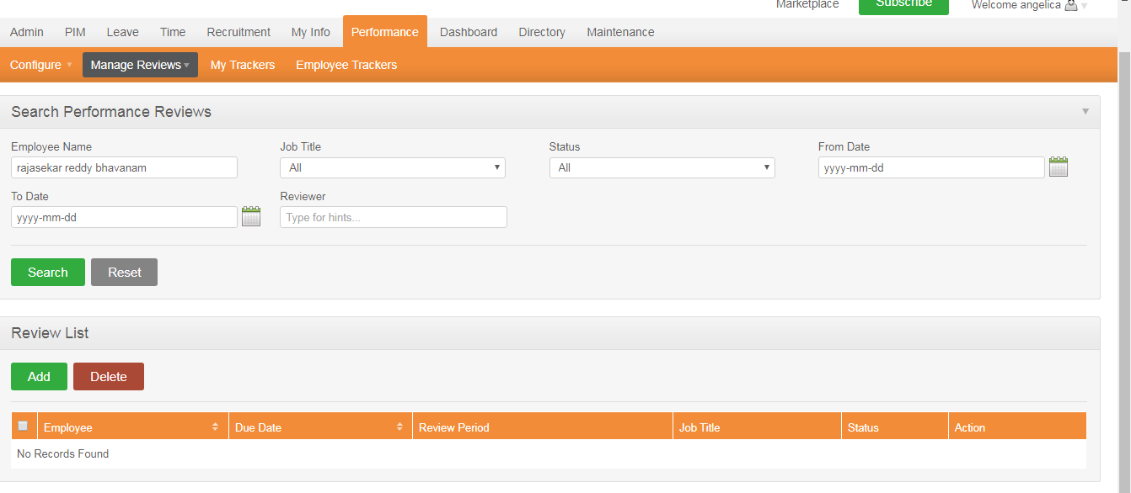

### 3.1.4 My Reviews

In the reviews sub-module the user can visualise the reviews he/she have given to a particular employee in his company.

Figure 3.1.4:

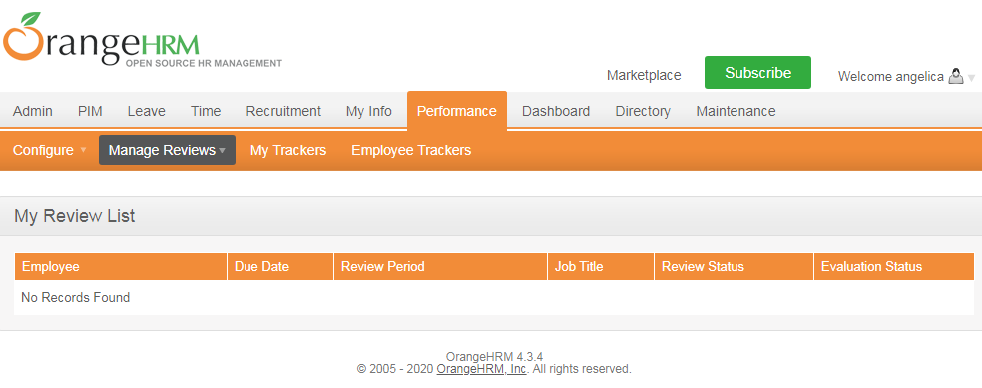

### 3.1.5 Review List

There is also an option for review list so that we can view the list of reviews for different employees and also search for the performance review of a particular employee by giving search hints on the Employee name.

Figure 3.1.5:

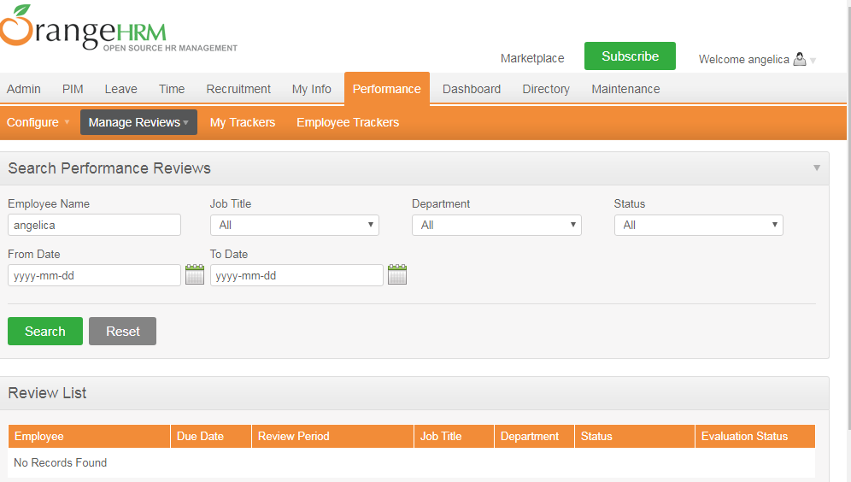

### 3.1.6 My Trackers

In this sub-module the user can see the reviews that he/she has got and so based on the hint and other info he/she can improve on his work approach. There is also an option for added date and modified date so that the user can get the clear picture or update about the tracking details.

Figure 3.1.6:

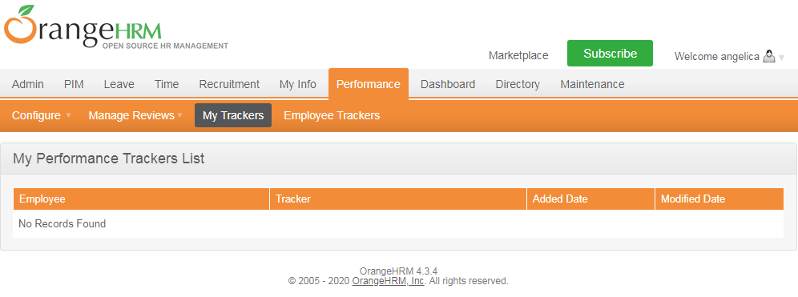

### 3.1.7 Employee Tracker

There is a sub-module for the performance module which helps us to track the reviews for employees in a single go so that it is very easy for the tracker to view into this and analyse it so that based on the reviews the HR can give different tasks to the employees based on their performance in different areas.

Figure 3.1.7:

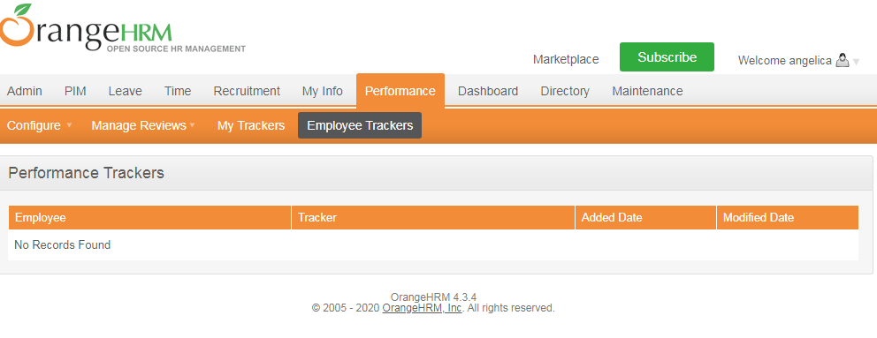

# 4.Sign-Off Document

_____________________________________________________________________________

The following parties have read and agree with this Requirements Definition document for the Orange HRM application account module functionality.

After approval of this Requirements Definition phase, any significant changes in the scope of this project will require validation of existing project costs and schedules.

_______________________________________________________________________

Name Date

Business Lead

______________________________________________________________________

Name Date

Project Manager

|  |
| --- |
| **Prepared by :**  **Angelica P A(845206)** |
|  |